DriverPass System Design Document

This document presents the UML diagrams and technical requirements for the DriverPass online driver training system. The diagrams are based on the owner's interview and the business requirements gathered in Project One.

UML Diagrams

UML Use Case Diagram
The use case diagram shows five kinds of users: the customer, the secretary, the owner, the IT officer, and the DMV. Customers can make, change, and cancel reservations online, register, take practice tests, check their test progress, reset their own password, and contact DriverPass. The secretary can do the reservation and registration tasks for customers who call or visit. The owner can view driver notes, print the activity report, download reports for Excel, and disable a package. The IT officer manages user accounts and resets access. The DMV sends update notices so the tests stay current.
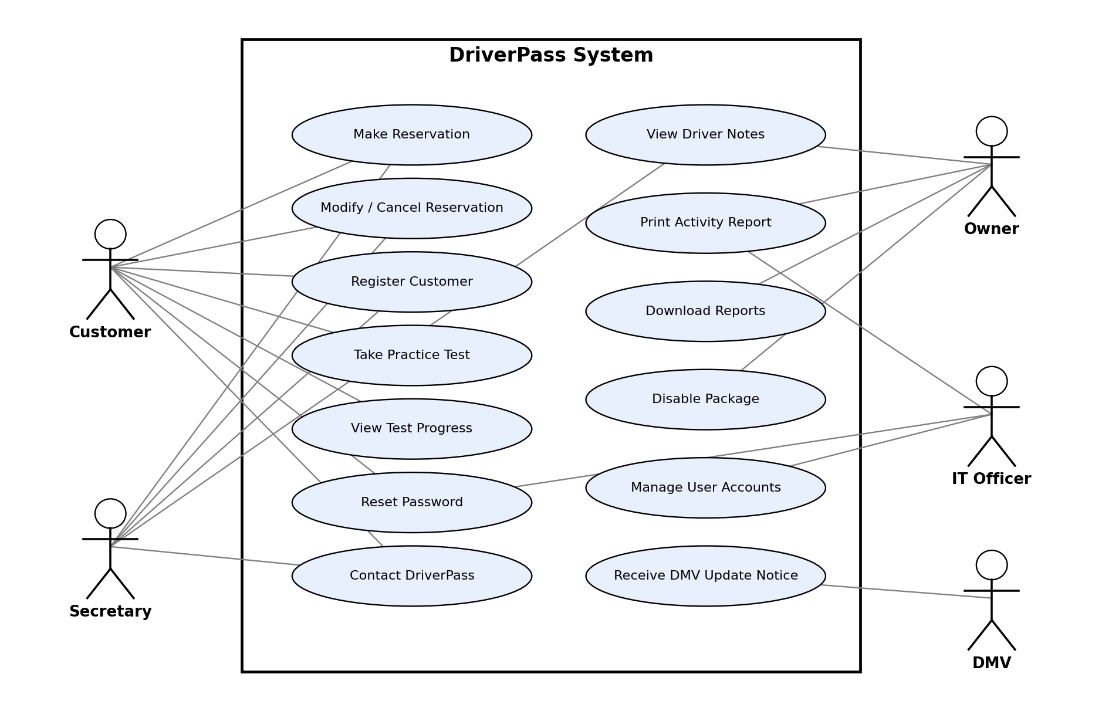
Figure 1. DriverPass use case diagram

UML Activity Diagrams
The first activity diagram breaks down the Make Reservation use case for a customer booking online. It checks the login, then the availability of a driver and car for the chosen two-hour slot, and records who created the reservation. The second diagram breaks down Reset Password, which lets customers recover their own account without calling the IT officer.
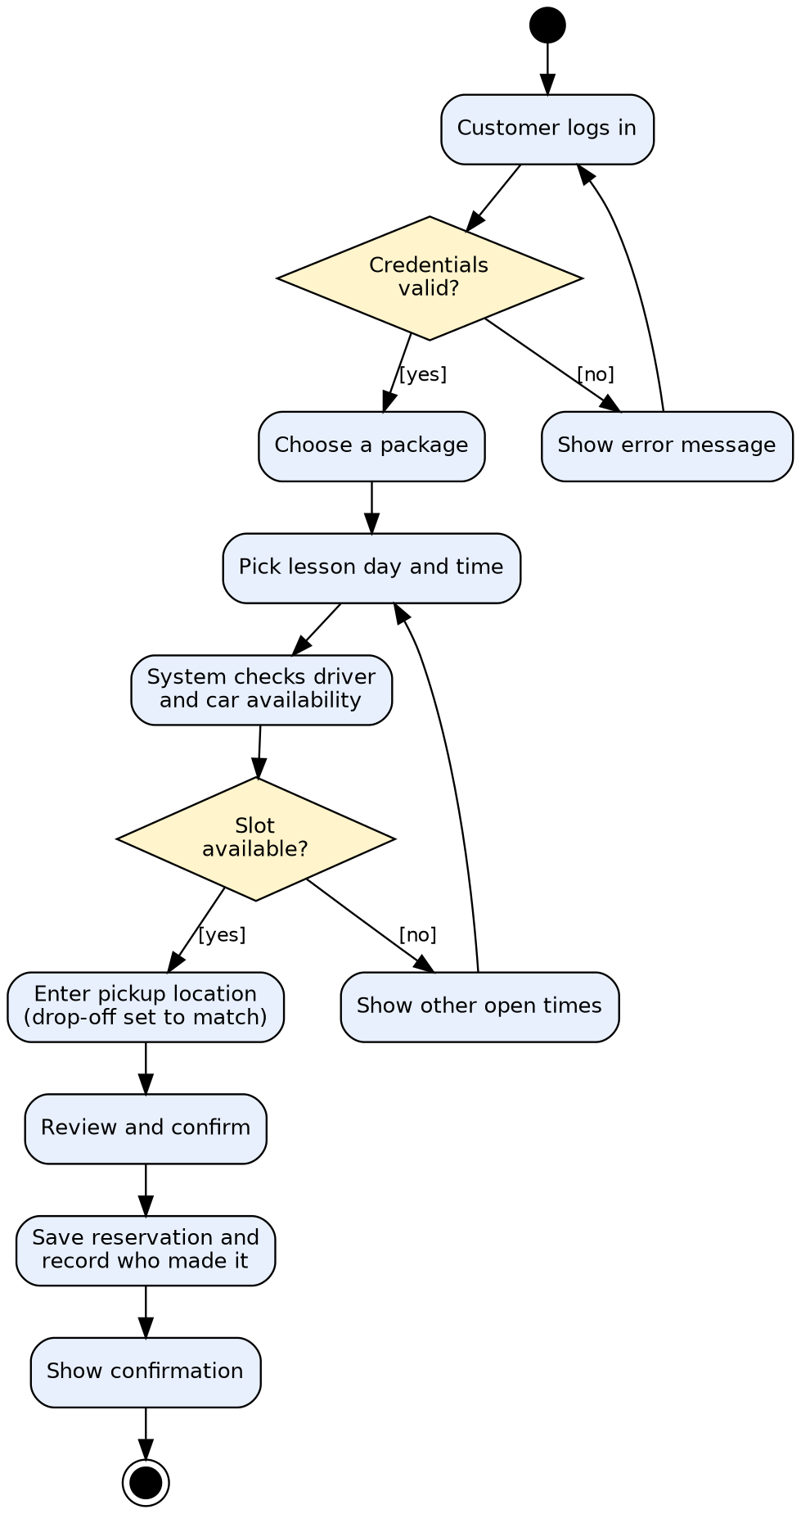
Figure 2. Activity diagram: Make Reservation
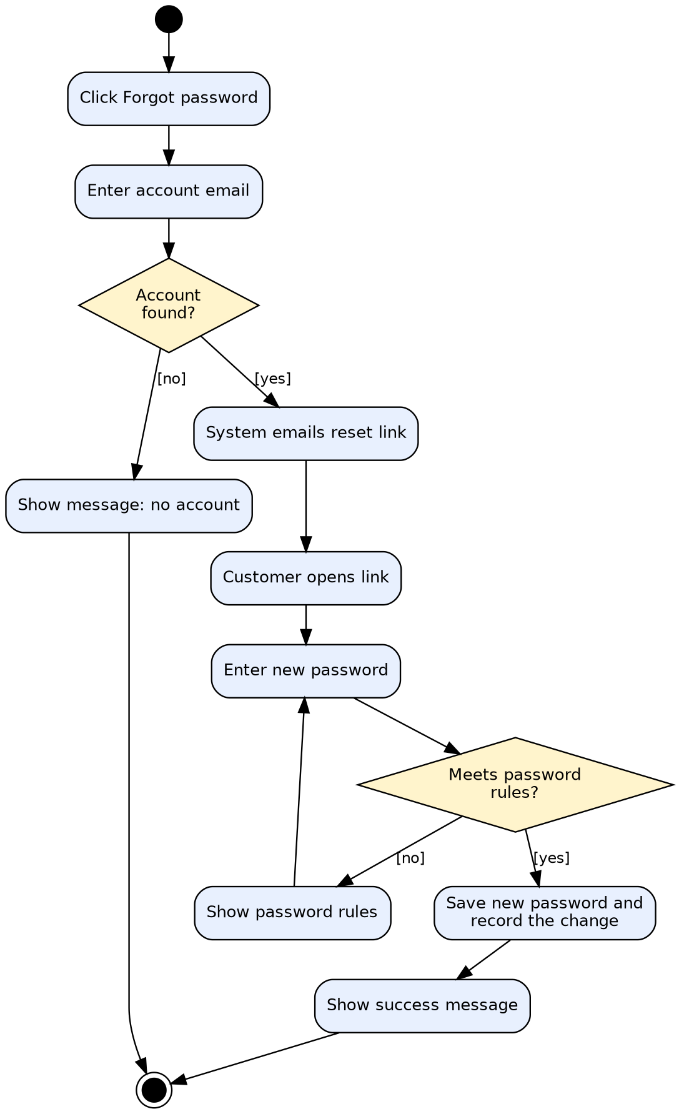
Figure 3. Activity diagram: Reset Password

UML Sequence Diagram
The sequence diagram follows the Make Reservation use case from the customer's request through the web portal, the scheduler, and the database. The scheduler finds an open driver and car for the requested time, the customer confirms the pickup location, and the portal saves the reservation and writes an activity log entry so the owner can later see who created it.
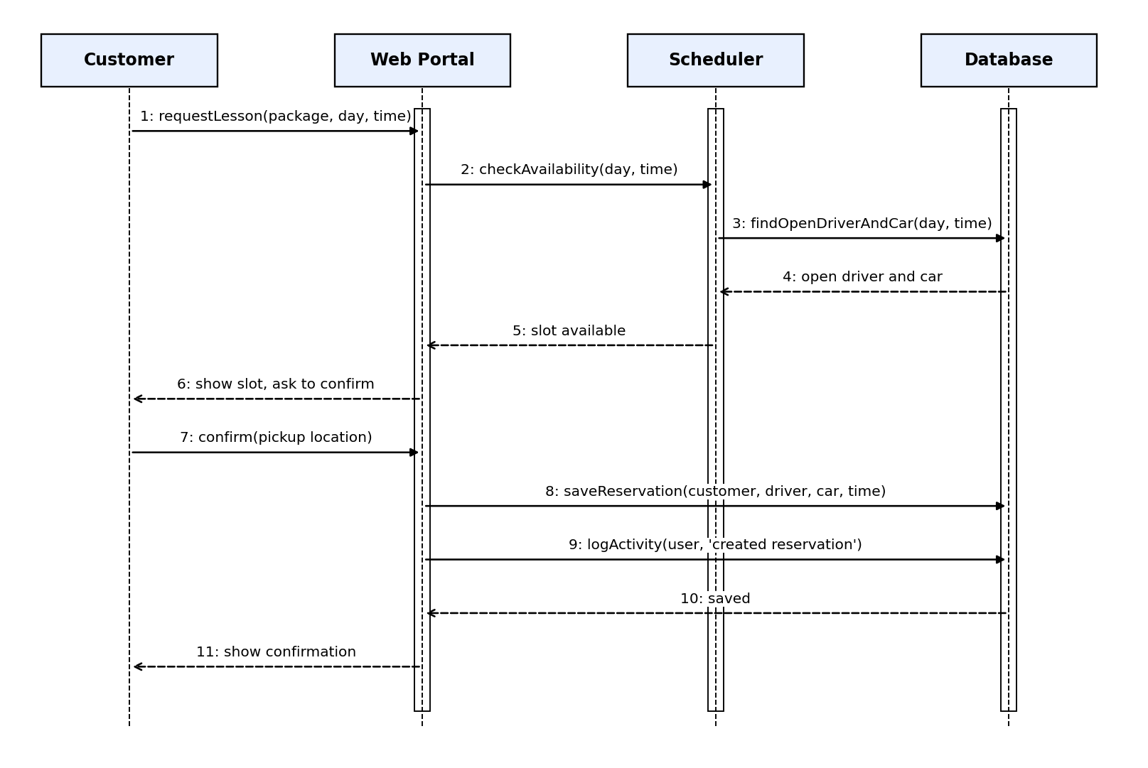
Figure 4. Sequence diagram: Make Reservation

UML Class Diagram
The class diagram shows the main records the system keeps. Customers and employees (including drivers) are kinds of users. A reservation ties together one customer, one package, one driver, and one car for a two-hour lesson, and keeps the pickup and drop-off locations along with who created and last modified it. Test attempts hold the test name, time taken, score, and status shown on the customer's progress page. The activity log records every user action for reporting, and DMV updates feed changes into the tests. Card numbers are not stored directly; only a token from the payment processor is kept.
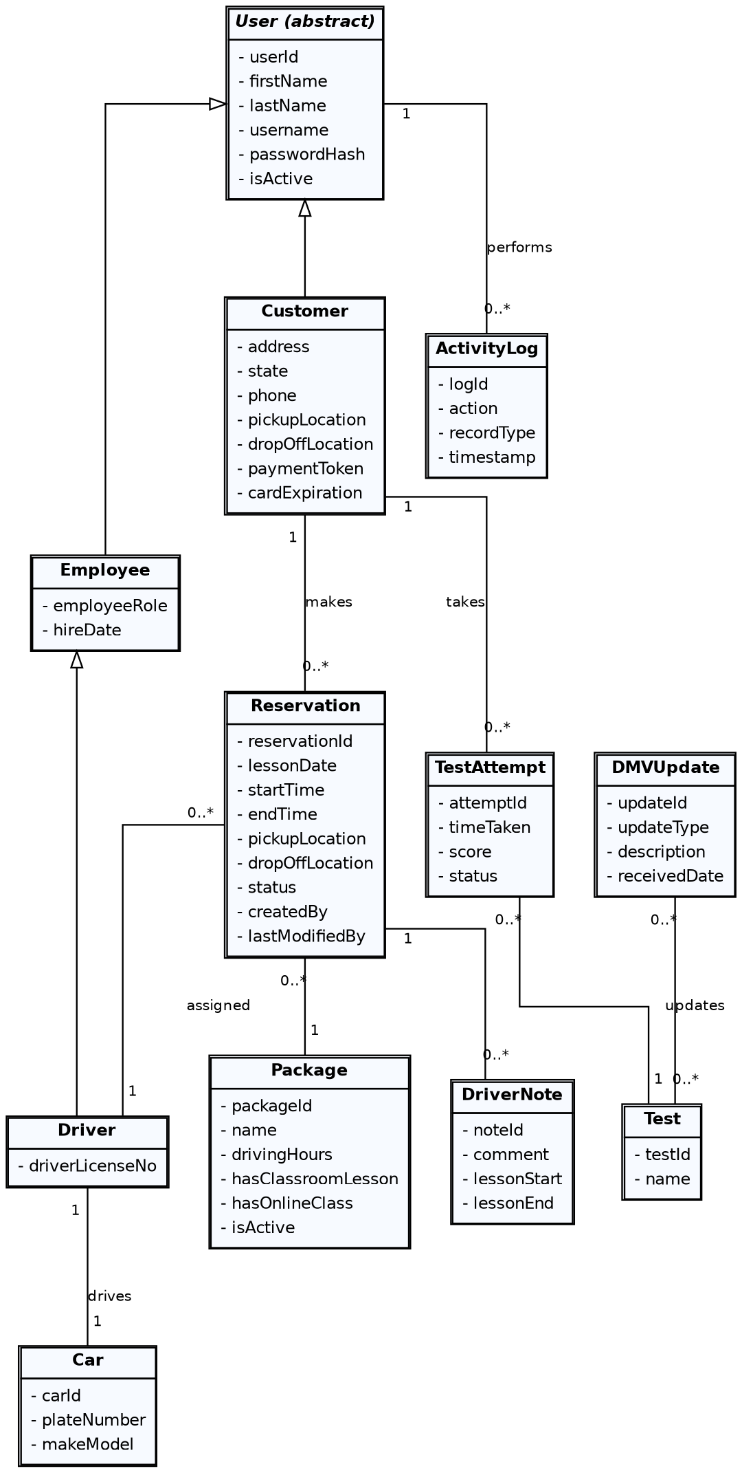
Figure 5. DriverPass class diagram

Technical Requirements
Hardware. DriverPass does not need to buy or maintain its own servers. The system runs on cloud-hosted servers, so the only hardware the company needs is ordinary computers, tablets, or phones for staff and customers, plus a printer at the office for activity reports. Any modern device with an internet connection and a current web browser (Chrome, Edge, Safari, or Firefox) can use the system, which satisfies the owner's request to reach his data from any computer or mobile device.
Software. The system is a web application with three layers: a browser-based interface built from the owner's sketch (reservation form, customer information form, test progress table, driver notes table, and a contact page), a business logic layer that enforces user roles and rules (such as two-hour lessons and one driver and car per reservation), and a relational database that stores users, packages, reservations, cars, drivers, test attempts, DMV updates, and the activity log. Role-based access control gives the owner, IT officer, secretary, driver, and customer different rights. Login and password reset use email-based reset links. Reports can be exported to CSV so the owner can open them in Excel. Payment cards are handled by a PCI-compliant third-party payment processor, so the system stores only a token and never the full card number.
Tools. The team uses Lucidchart for the UML diagrams, a version control system for source code, an automated test tool for regression and security testing, and the cloud provider's monitoring tools to watch uptime and errors. An email service sends password resets and DMV update notifications.
Infrastructure. The cloud provider handles backups, security patches, and server redundancy, since the owner does not want to manage them. Data is encrypted in transit (HTTPS) and at rest, and backups run automatically every day. Changes to data require an internet connection so that offline copies cannot create duplicate or conflicting records; offline access is limited to downloaded reports. A secure connection to the DMV (through an API or scheduled feed) delivers new rules and sample questions, and the system notifies the owner and IT officer when an update arrives.

